FAILURE CAN SUCCEED

OUTLINE

INTRODUCTION

I. God did not fail in the Creation

II. God did not fail in Redemption

A. He did not fail in the Crucifixion

B. He did not fail in the Resurrection

III. He shall not fail in the Restoration

IV. God Shall Not Fail In Your Ministry

A. Failing is not failure

B. Failing is only a temporary set back

C. It is not a disgrace to fail, unless you quit

D. Losing a battle is not losing a war

E. Each failure can equip you with a new tool for success

CONCLUSION

A. God’s saints illustrate His success in the instruments of failure

B. We can never, in our ministry, discourage God

C. God writes man’s last chapter with a success story

# Introduction

Failure **can** succeed. That’s the beautiful thing. That’s the encouragement. And the hope that we have in the Lord Jesus. We will begin by reading from Isaiah 42:1-4 & 9

*“Here is my servant, whom I uphold, my chosen one in whom I delight; I will put my Spirit on him and he will bring justice to the nations. He will not shout or cry out, or raise his voice in the streets. A bruised reed he will not break, and a smoldering wick he will not snuff out. In faithfulness he will bring forth justice; he will not falter or be discouraged till he establishes justice on earth. In his law the islands will put their hope.” And then verse nine “See, the former things have taken place, and new things I declare; before they spring into being I announce them to you.”*

Failure and discouragement. They almost always go together. You had a hope. You had a plan*,* and it did not work out. You experienced failure. And what happens? The adrenaline all goes down to your toes. With your last ounce of energy, you throw up your arms, and you say, “It is no use!I cannot do it anyway.” And you give over to discouragement. So, failure and discouragement--they are ***the twin sisters of despair***. And that is the very thing you do not want. You do not want despair.Proverbs tells us that the difference between a righteous man and an ungodly man is that they both fall down many times, but the righteous always gets up again.

So, when something goes wrong in your ministry, and people feel pretty bad, guess whose responsibility it is to feel good! The leader’s responsibility! Remember, the leader’s responsibility is to always be thinking, planning, working in the future. So, it is his responsibility to motivate the team again through encouragement and enthusiasm. “I understand, brothers and sisters, our motorcycle fell over, we have all fallen off, we have all gotten hurt. But I want to tell you something. That will never happen again, because now we are going to buy a car, and we cannot fall over.” You have a ***new*** vision that you give the people for the future.

We can never appreciate God’s success unless we view it in the light of man’s failure. So, when you see God’s success, you automatically see man’s failure.

Paul came to only one conclusion, “In this weakness, I am made successful.” And without failures, you will not learn from mistakes or problems or difficulties, and you will not be able to do better. So, it is your responsibility as leaders to turn failures into stepping stones.

# I. God did not fail in the Creation

Whenever He created something, He stood back, He looked, and He said, “It is very good.” Now, man’s tendency is to say, “It is very good -- someplace else. Not right here. Someplace else. Not now. Maybe it was a year ago. Or, not now, but maybe it will be.” God, step by step, was successful in the Creation.

# II. God did not fail in Redemption

### A. He did not fail in the Crucifixion.

Jesus was tempted to avoid the Crucifixion, avoid the suffering. To avoid the problems. If He would have just taken a shortcut, satan was going to give Him all the kingdoms. But, He was successful by carrying out God’s plan of Redemption on the cross. He had a goal and while everybody felt bad and discouraged and thought it was a total failure, He was successful.

### B. He did not fail in the Resurrection.

He did not fail in the tomb. They put Him away for good. They closed off the cave. They sealed it. They thought, “Three days and we can forget this. It is finished.” God did not need three days. Before they were finished, Christ was resurrected. Because of the Resurrection, we have the book of Acts. In the book of Acts we read of thousands of people who were dead, and God resurrected them. The church has been growing and resurrecting people ever since.

We are in the valley of dry bones -- people who are dying and have died in their sins. Billions of them. A world full of them. But, they are being resurrected. They are coming together. Flesh is coming on them. They are standing up, and it is going to be a great army, because of the Crucifixion and the Resurrection.

# III. He shall not fail in the Restoration

The Church represents the first fruits of Redemption. It is only the first fruits. There is more to come. This is not the end of everything. It is not just fifty-five years or sixty-six years or seventy-seven years. It is only the first fruits. And then we have all of eternity.

Man has discovered this secret of success over failure. People that were in bondage. People that had failed. They looked up at the cross. They saw the blood of forgiveness dripping from that cross. They realized that there could be no forgiveness without the shedding of blood. And they said, “Thank You, Jesus!” All of you know people who have been totally changed, who have discovered complete success over failure.

# IV. God Shall Not Fail In Your Ministry

He shall not fail in your ministry. God has already been successful in all the other things. He had a plan to start with. Jesus came in the fullness of time--at the perfect moment. With just the same plan and in just the same perfect moment, He has given you the privilege to participate, and the opportunity to be successful. We want to look here at four principles that make failure a success:

### A. Failing is not failure.

One of my neighbors is an elderly man. He usually talks out loud to himself. Sometimes he sits there on one of the benches somewhere, but quite often he cannot do that, and he lays beside it on the ground, or on the concrete, or in the grass. He represents a failure. He is finished with his life. He has no lifestyle left. Liquor is his boss. And there is nothing he can do about it. That represents failure.

Failing at a task, however, is not the same. It is simply saying, “This time we did not advance as far as we had planned to.” Or, “We discovered this was not as we had planned or thought was God’s will.” Or “We had underestimated satan’s attack or satan’s strength.” So maybe your Mission, church, or organization did not get model status. Nine months later you will probably get model status. There will be a second opportunity.

### B. Failing is only a temporary setback.

There will be a new chance. This is only a temporary setback. It is only stumbling for the moment. Yes, it is scary when you stumble. Yes, it may hurt a little bit when you fall. True, for a while you may limp. But you are going on. That is where the success is: in going on. That is the difference between failing and failure. Proverbs tells us that is the difference between the righteous and the ungodly.

### C. It is not a disgrace to fail, unless you quit.

If you do not quit, your testimony turns out to be just the opposite from failure. A little bit later on, people will say, “You know, I would have never thought he could do all of this.” Or, “I would have never thought he would be able to remedy that situation.” Or, “I would have never thought that he would have hung in there and continued with this.”

When I was a young man, I was working, and I became very discouraged. I felt discouraged for several months. This was not for me. I was working for my uncle on a farm, and I did not like any of it. But I had a contract, and so I stayed there and I got up every morning, worked every day, went to bed, and got up.

About four or five months later, I had the opportunity to go away and do some other things. Then I talked with my uncle about the discouraging time I had in October, November, ...etc. I told him that I was discouraged at that time. He said, “Yes, I know. I told your aunt, ‘We are going to see Abraham standing at the end of our lane by the gate with his suitcases tomorrow.’” He apparently said this several times to his wife, but it did not happen. I did not give up. I did not quit. I stayed right there. Two months later my uncle came up with a better plan.

### D. Losing a battle is not losing a war.

Yes, you would like to win every battle. That is normal. Yes, you would always like to be on top of the mountain -- have a mountain top experience. But how many people do you know that live there on top of these mountains? It seems like nobody stays up there. They all want to get up there, then once they have had this experience, they come back down. And it is harder to come down. It is harder because that is when we think of the defeat. We think of the disgrace. We think, “But, ahhhhh, it was so nice.” And now we have to do this all over again.

You just have to remember that losing the battle is not losing the ***war***. God is successful. He will build the Church and the gates of Hell cannot prevail against it. We already have New Life for Churches training all over this land, and God is blessing us in many other places as well.

### E. Each failure can equip you with a new tool for success.

As long as things are going good, you will keep on doing what you are doing. When things go bad, you are forced to analyze your situation. You are forced to reorganize. You need a new plan. New tools. Perhaps new helpers. Then, **because of this failure**, you are one step closer to success.

I forget how many times Abraham Lincoln tried to become President of the United States. Seven times, I think, all together. He tried for a Government Post, a State Governor, and some other positions. Failure, after failure, after failure. In the end however, he was successful, and then he was killed. And yet, he is the great man in American history that the whole world reads about and admires as a hero.

# Conclusion

### A. God’s saints illustrate His success in the instruments of failure.

God’s saints illustrate, not their own success, but **His** success. When Moses went to spend forty days with God, at that very moment the problems began. There was trouble in the camp. All the heavenly forces were fighting against God. The Ten Commandments were broken, and it looked like everything was lost, but God won. Moses was successful. A new set of Ten Commandments was written. A Tabernacle was built. A nation was born: God’s special people.

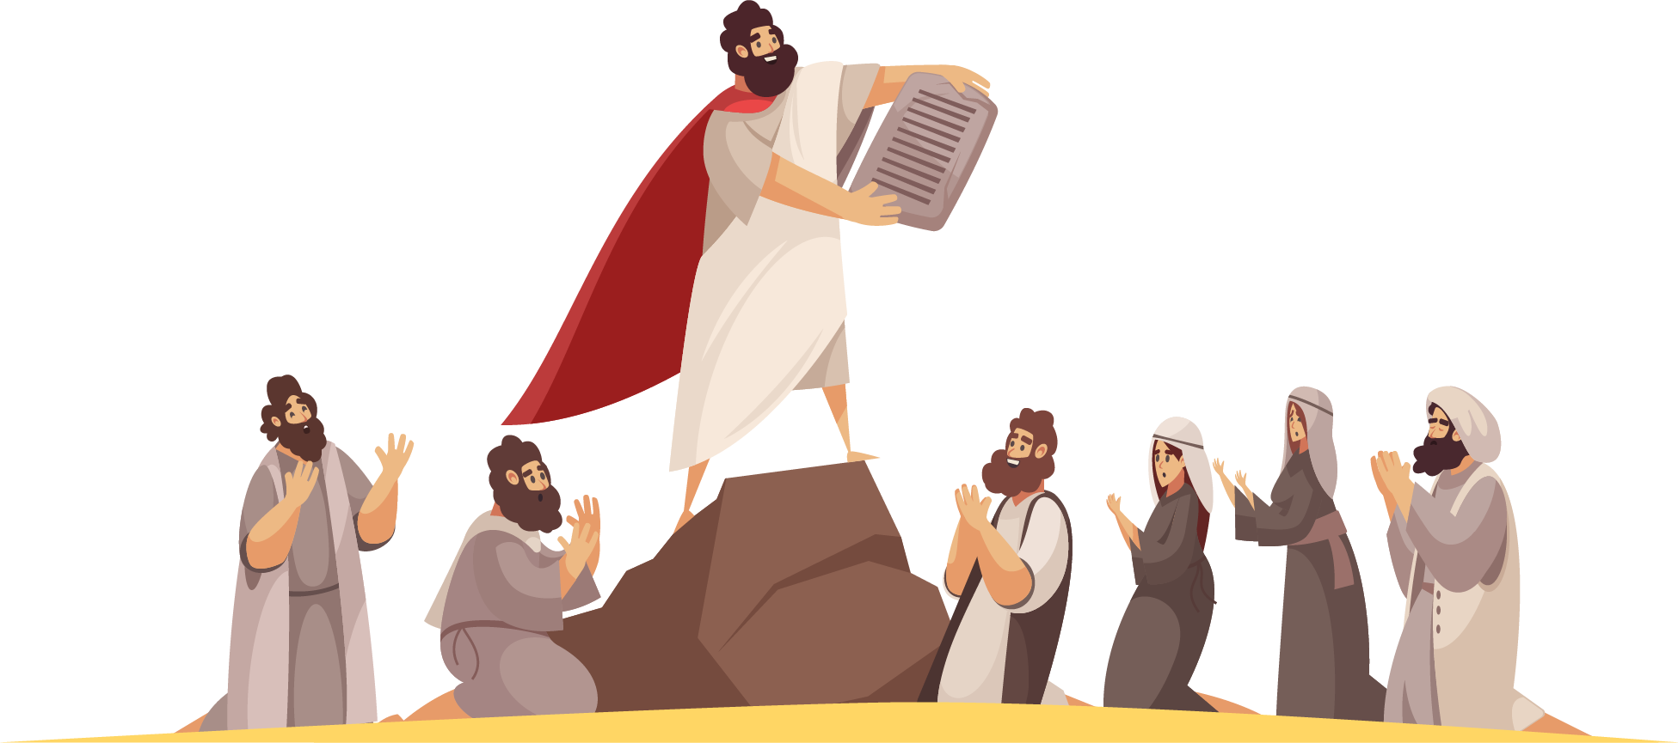David wanted to bring the Ark of the Tabernacle to the main city. Just at that time, there was a satanic attack. An accident happened. A person died. What was intended to be a highlight, turned out to be a failure. Yet, years later, a beautiful building was built. Tons of gold were used and the glory of God that had been in the wilderness was once again in the new temple with the Ark of the Covenant.

### B. We can never, in our ministry, discourage God.

This is the most encouraging thought you could possibly think. There is nothing you can do to discourage Jesus, so that Jesus will turn around, and say, “Well, I am going home. I am quitting. My whole program for the church is finished.”

Elijah, when he was serving God, became discouraged. And when he looked at the results, his accounting was wrong by 6,999. That is how wrong he was, because he said, “God, You might as well quit, because I am the only one, I am the last one. Just take me to Heaven, close the books, have it over with, finished.” God says, “What are you talking about? You are 6,999 points wrong.” You can never in your ministry discourage God.

### C. God writes man’s last chapter with a success story.

***We can never, in our ministry, discourage God.***

God will write the last chapter of your life, and He will write it a success story. There will be the false accusers accusing you of all the failures in your life. And then, the Lord of Lords will say, “Well done, thou good and faithful servant. Welcome, enter the joy of your Lord.” Praise God that failure can succeed! Amen!

Blessings to you, our dear friends!

We are happy to present the video, audio and paper materials that have been prepared by New Life for Churches. You have the privilege